
TCC 6313 Cloud Computing (Trimester 2510)

Lab 1 - Introduction to AWS IAM (2%)

STUDENT ID | 1211112228
STUDENT NAME | MUHAMMAD EUSOFF AMINURRASHID BIN SHUKRI
PROGRAMME | ST

Follow the instructions from AWS Lab Academy: Lab 1: Introduction to AWS IAM

Answer the following questions.

Question No. | Snapshot/ Answer
- Screen shot your Start Lab session showing Lab status = ready. (1m)
i. | 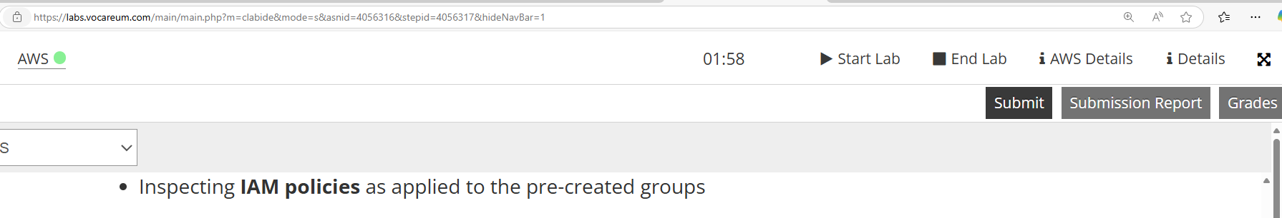
- AWS console URL. (1m)
i. | https://us-east-1.console.aws.amazon.com/console/home?region=us-east-1#
- Sign-in URL for IAM users in the account. (1m)
i. | https://975050033125.signin.aws.amazon.com/console

- Screenshot IAM Dashboard. (1m)
i. | 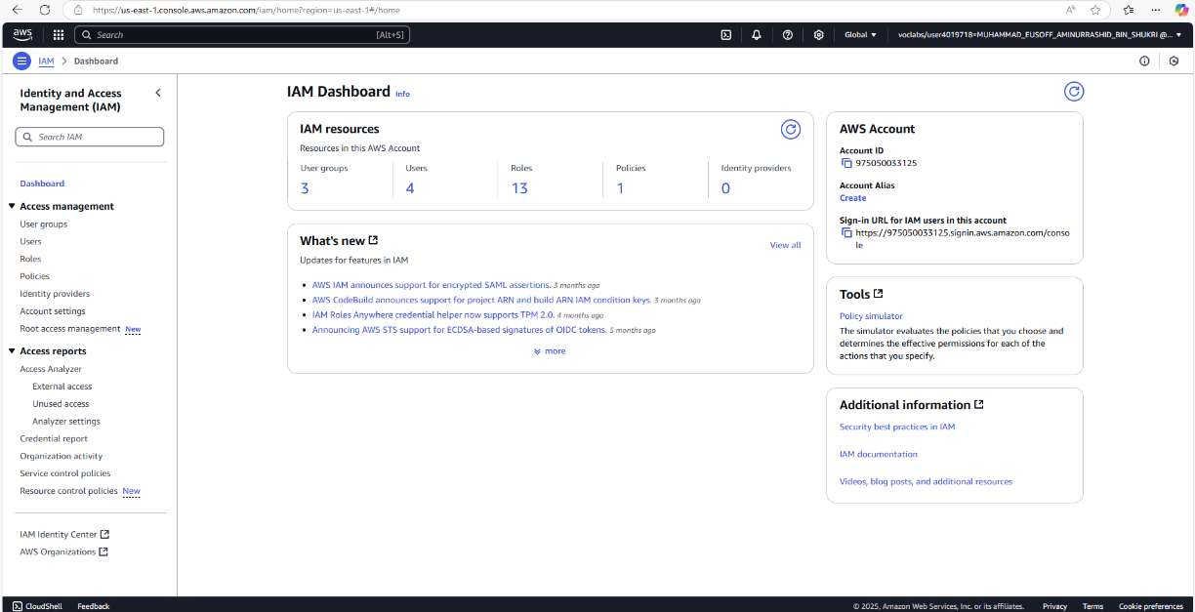
- Screenshot IAM user page showing 3 accounts. (1m)
i. | 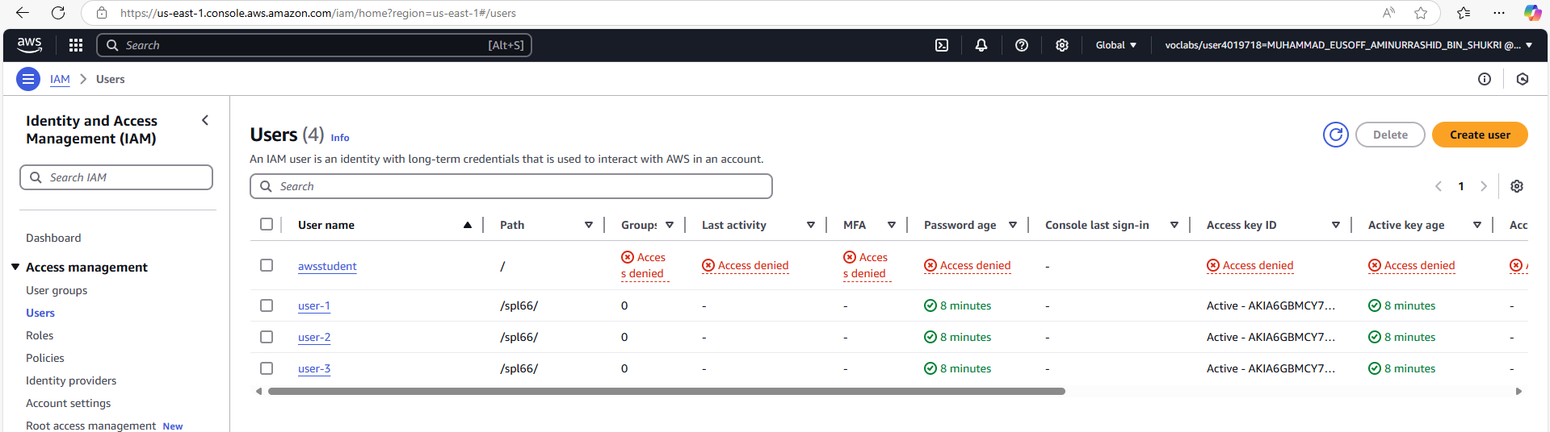
- Screenshot IAM user groups page showing 3 groups name. (1m)
i. | 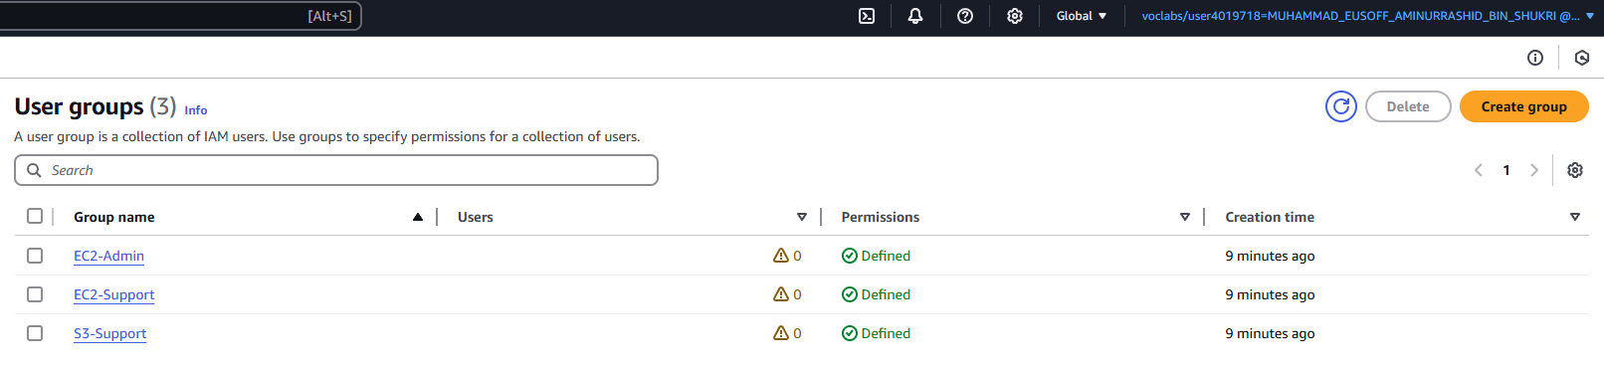

- Show user that been assigned to the EC2-Admin. (1m)
i. | 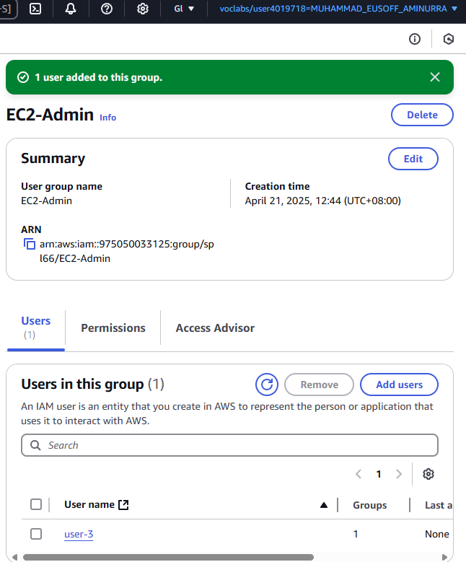

- Show user that been assigned to the EC2-Support. (1m)
i. | 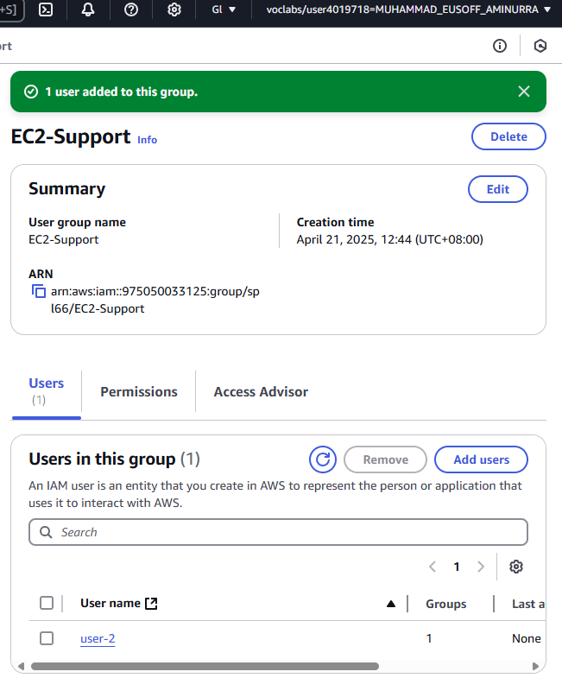

- Show user that been assigned to the S3-Support. (1m)
i. | 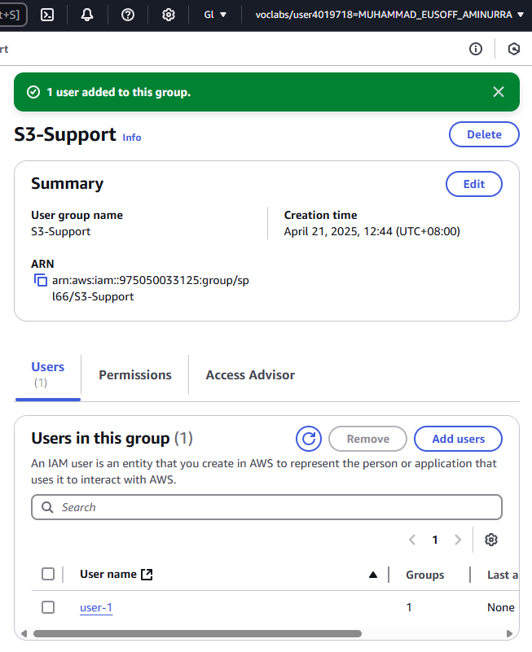

- Show Lab Host instance has been stopped when you login as user3 in IAM users sign-in link. (1m)
i. | 